Phase 2: Backend Development & Configurations
Data Architecture

Description
The Data Architecture phase focuses on designing and configuring the backend data structure required to support the Automated Network Request Management solution in ServiceNow. This includes creating custom tables, defining fields with appropriate data types, and ensuring data consistency, scalability, and integration with automation workflows.

Activity 1: Creation of Table
Description
This activity involves creating a custom table to store structured network request data.
Steps
- Navigate to System Definition > Tables
- Click New to create a new table
- Fill in the table details:
  - Name: Network Database
  - Label: Network Database
  - Auto-generate schema: Enabled
- Click Submit to create the table

Outcome
A custom table is created to store and manage network request records centrally.

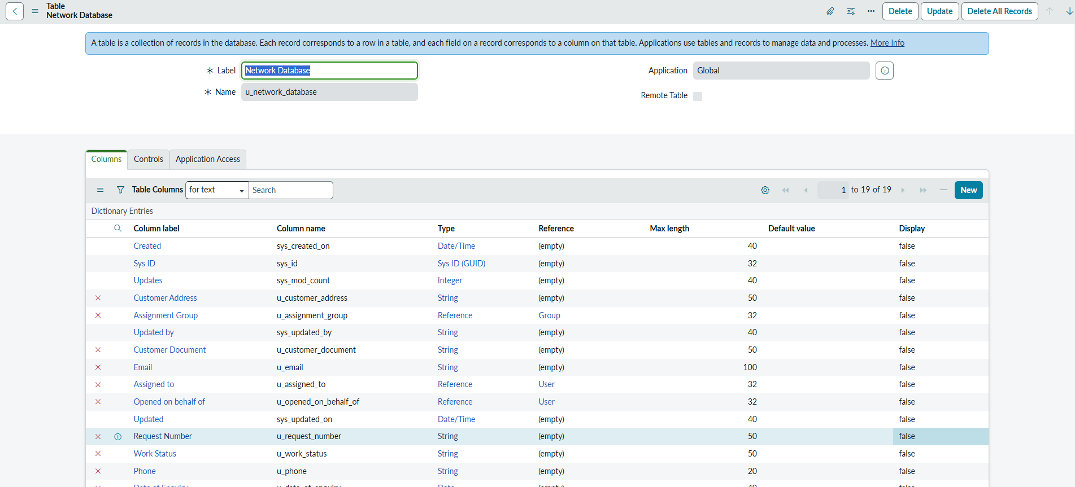

Activity 2: Creation of Fields
Description
Fields are created at the table level to capture required data attributes.
Steps
- In the Application Navigator, search for Tables
- Navigate to System Definition > Tables
- Search and select Network Database
- Open the Columns tab to view existing fields
- Click New to add a new field
- Proceed to define field properties

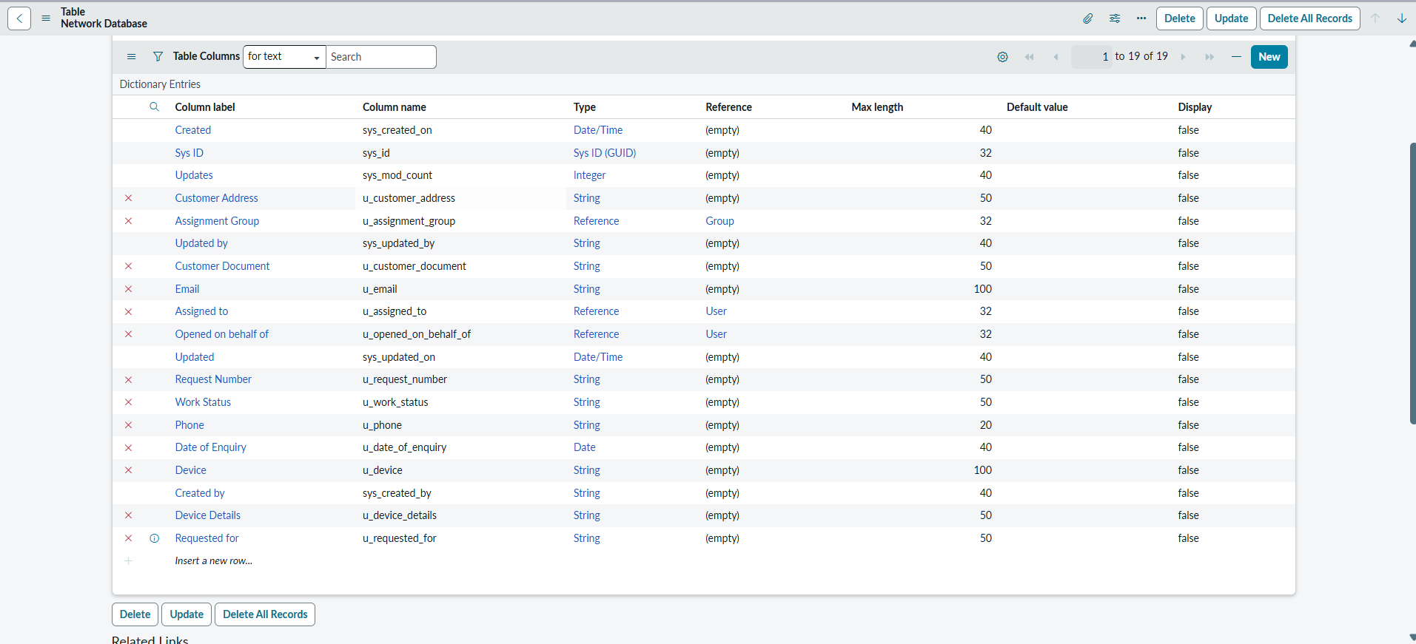

Activity 3: Define Field Properties
Description
Field properties define how data is stored, validated, and displayed.

Field Configuration Details
- Column Label
  - Display name on forms and lists
  - Example: Customer Name
- Column Name
  - System-generated internal name
  - Example: customer name
- Field Type
  - Defines the type of data stored
  - Common types:
    - String
    - Integer
    - Choice
    - Reference
    - Boolean
    - Date
    - Date/Time
  - Example: String, Choice, Reference
- Max Length (Optional)
  - Applicable for String fields
  - Example: 255 characters
- Mandatory
  - Enforces required input
  - Used for critical fields
- Default Value (Optional)
  - Auto-populated value on record creation
- Read-Only
  - Prevents manual modification
  - Used for system-generated fields
- Save Field
  - Click Submit or Save to create the field

Activity 4: Add the Field to a Form (Optional)
Description
Fields can be added to forms to allow user interaction.
Steps
- Navigate to System UI > Forms
- Select the required form
- Open Form Designer
- Locate the newly created field in the Field Navigator
- Drag and drop the field onto the form
- Click Save or Publish
Testing
- Open a record from the Network Database table
- Verify field visibility and behaviour
- Validate mandatory, read-only, and default values

Key Field Types in ServiceNow
- String: Short text input
- Integer: Whole numbers
- Choice: Dropdown selections
- Reference: Links to other tables (e.g., User table)
- Date / Date-Time: Date pickers
- Boolean: True/False checkbox
- Currency: Monetary values

